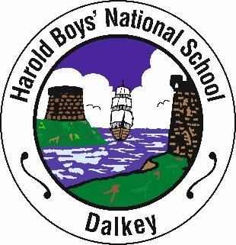 Harold Boys’ National School

St. Patrick’s Road,

Dalkey

Co.Dublin

Phone/Fax: 01 2856193

Email: [info@haroldboysdalkey.ie](mailto:info@haroldboysdalkey.ie) Website: [www.haroldboysdalkey.ie](http://www.haroldboysdalkey.ie)

Principal: *Pauline Lennon*

**BOOK LIST – SECOND CLASS 2024-2025**

**Class teacher: Ms Molloy**

**Please purchase:**

* 1 x Tin Whistle- Key of D
* 1 x zipped folder
* 1 x 40 pocket display book
* Packet of colouring pencils or twistables
* 5 pencils, 2 erasers, 1 sharpener, 1 ruler (30 cm), 2 Medium Pritt Sticks

**All books, workbooks and copies will be supplied free of charge under the Department of Education Primary School Book Scheme**

| Art & Craft Materials | €20 |
| --- | --- |
| Photocopying, Stationery, Notices | €25 |
| Supplementary Materials | €25 |
| Homework Notebook (available from School only) | €6 |
| Computers | €110 |
| Basketball | €16 |
| Dabbledoo Music and Drama Programmes | €4 |
| Allianz Personal Accident Insurance | €9 |
| Total | **€215** |

***Please pay the above amount online through Aladdin Connect before 17th August 2024***