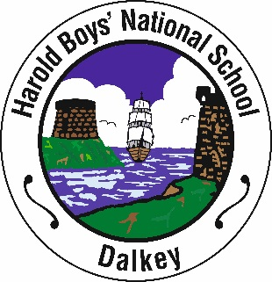
Harold Boys’ National School
St. Patrick’s Road,
Dalkey
Co.Dublin
Phone/Fax: 01 2856193
Email: info@haroldboysdalkey.ie Website: www.haroldboysdalkey.ie
Principal: Pauline Lennon

School Opening Times
8.50 a.m. – 2.30 p.m.

Please take note of the following:-

The gates of Harold Boys’ National School will open at 8.45a.m. to receive pupils. No responsibility is accepted for pupils arriving before that time.

All pupils are expected to be in their line by 8.50 a.m.

No pupil should arrive later than 8.50 a.m. Classes will end at 2.30 p.m. Parents who wish to have their children escorted home should make their own arrangements to have them met at the school gate and the person to escort them should be at the school gate no later than 2.30 p.m. as the school cannot accept responsibility for the child after thst time.

Yours faithfully

Pauline Lennon
Principal

